Name: Sejal Dhande

PRN: 21070521115

Subject: GenAI

CA2 Assignment

Q.1 Generate a model in Python for representation of a bank account of type savings and balance along with transactions of deposit and withdrawals and currently create a program to generate 100 accounts with Random balance and transactions for no. of months and no. of transactions with a seed value of amount. Print all 100 accounts with the last balance and organize them by lowest to highest balance.

Solution:

1.Import libraries:



2.SavingsAccount Class:

* Represents a savings account with methods to deposit and withdraw funds.
* Keeps track of the account ID, balance, and transaction history.

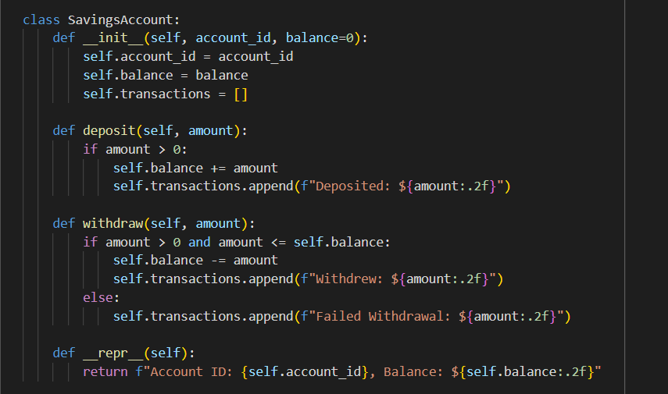

3.generate_accounts Function:

* Generates a specified number of accounts with random initial balances.
* Simulates a specified number of months and transactions for each account.
* Deposits and withdrawals are randomized within certain limits.

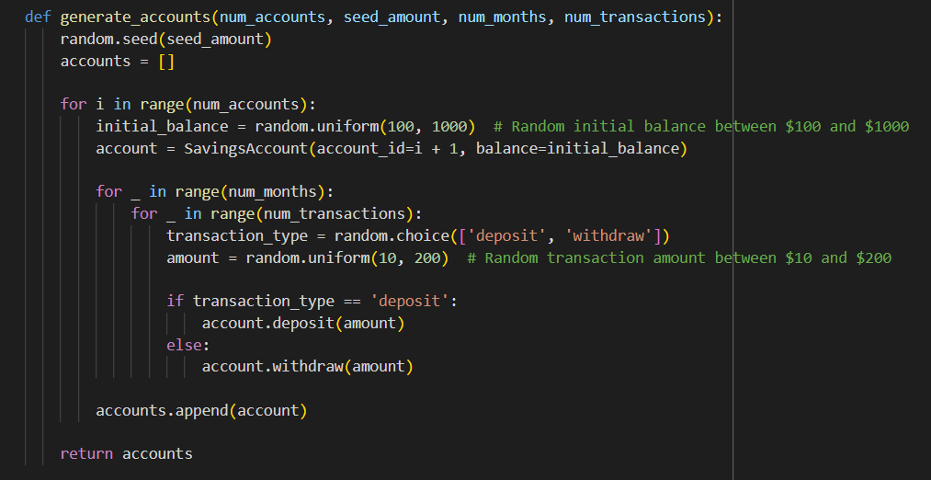

4.Main Function:

* Sets parameters for the number of accounts, seed, months, and transactions.
* Calls the generate_accounts function to create the accounts.
* Sorts the accounts by balance and prints them.

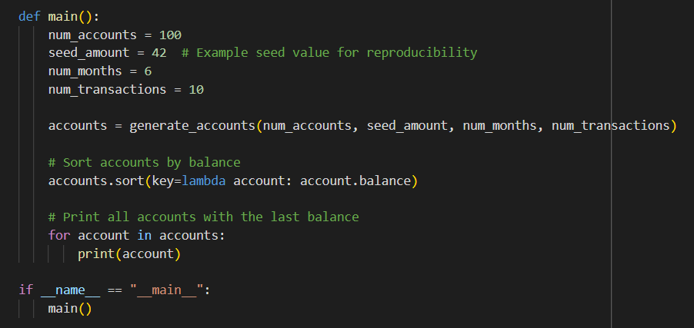

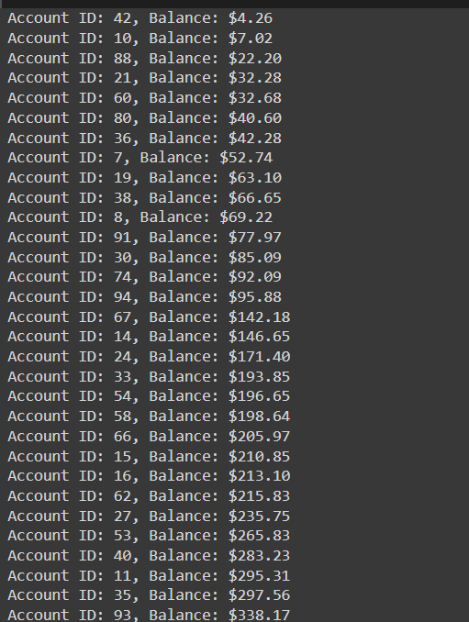Output:

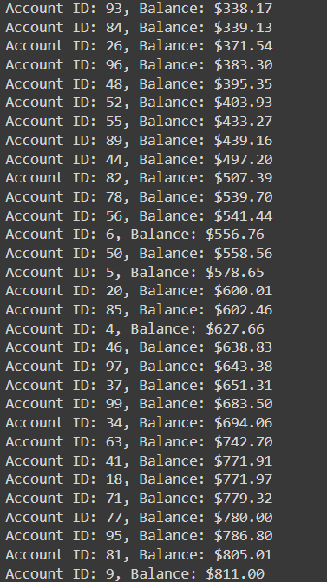

Q.6 Generate a model to represent a mathematical equation, write a program to parse the equation, and ask for input for each parameter.

Solution:

1.Import Library: Import the re module to help find variables in the equation using regular expressions.



2.Parse the Equation (parse_equation function):

* Find all variables (e.g., m, x, b) in the equation, except y, by extracting letters.
* Return a list of unique variables.

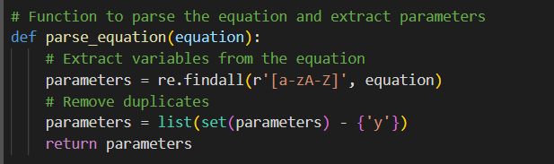

3.Get User Input & Evaluate (evaluate_equation function):

* Ask the user to input values for each variable.
* Replace the variables in the equation with these values. Use eval() to compute the result of the equation.

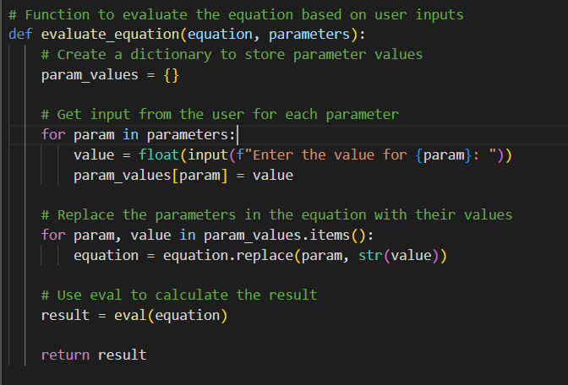

4.Main Program:

* Define the equation y = m*x + b.
* Parse the equation to get the variables (m, x, b). Ask the user for the values of these variables, evaluate the equation, and print the result.

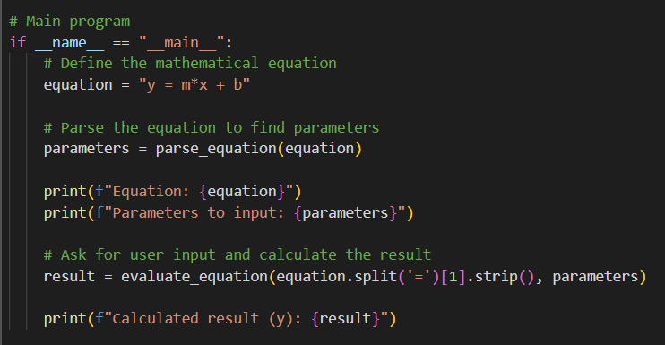

Output:

